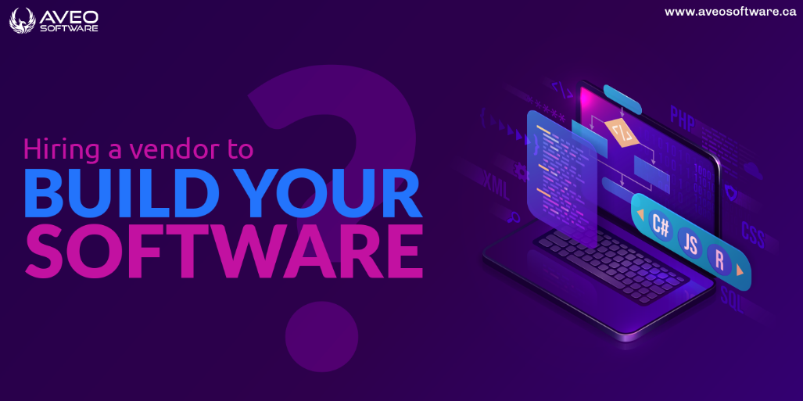

**Hiring a vendor to build your software? Here’s what to consider when evaluating agencies**

Whether you are a novice user of software or a seasoned pro, you will occasionally require the [**assistance of a software developer**](https://href.li/?https://aveosoftware.ca/custom-software-development/). You might require software that meets your needs or want to improve the way your program is designed. In any scenario, you will require a software developer to complete the job.

However, the market is flooded with software developers. The technologically advanced world offers choices that may cloud your decision. For instance, in 2020 there were [**1.49 million software developers working in the US**](https://href.li/?https://www.statista.com/statistics/258157/number-of-software-developers-employed-in-the-us/). By 2034, there will be 1.84 million more. These figures illustrate the uncertainty you may experience when looking for the best software developer. The ideal software developer should cater to the unique wants of the customers with high-quality services. Importantly, choosing the wrong vendor is where your failure will begin.

At present, Canadian cities are the top-performing, rapidly expanding technology hubs. The growth of IT specialists has coincided with the spread of technological advancement. A popular career in Canada is software development. The top e-commerce in the world has announced a significant hiring drive for software developers in Canada. Canada reported a 73% rise in job posts for software development in 2021.

These factors have led to a large number of software development firms in Canada. It is therefore difficult to find the correct developer in the sea of these engineers. Calgary, for instance, is the center of Alberta, Canada's digital transition. Between 2021 and 2024, it will invest [**$20 billion in digital transformation**](https://href.li/?https://www.calgaryeconomicdevelopment.com/sectors/technology/)**.** The world's biggest problems are solved by software companies in Calgary.

The answer to today's changing company needs is custom software. As a result, finding the ideal SaaS tool is difficult. But we are here to guide you in understanding what factors to take into account when evaluating vendors.

“When to use iterative development? You should use iterative development only on projects that you want to succeed.”

Martin Fowler

**What to consider when evaluating software development agencies?**

Before committing your funds to a software development agency, consider the following.

**1. Make a needs assessment first**

It's imperative to first determine your particular needs before going shopping. How can the developer know what features you require in the product if you are unable to identify them? Many people won't tell you this, though. You must first determine what your needs are, though, before you can check on anything else.

Ask your staff what functions they feel are essential to include in the new program. Distinguish these qualities from others that could be improved but are not required. Focus on the particular program elements or designs you require. You can effectively express it to the developer in this way. Finding a developer who meets your demands will be simple.

**2. Check on vendor credentials**

Credentials are a group of terms that instruct you to investigate a number of issues. Even before you know who the vendor is, you must research their history. For the majority of these developer companies, the internet offers a range of data silos. Their culture, rules, and customer service are all available for reading and understanding. insists on being informed of their registration or certification. It seems safer to work with a credentialed software developer.

Importantly, don't neglect to look into their most recent market performance. Check to see if the business is expanding or contracting. It will provide information about the company's customer satisfaction levels. You run the danger of losing your hard-earned cash if you join a downsizing company.

**3. Reputation**

Software developers are proliferating, making it difficult to determine who is reliable. Each and every service seeker needs to have trust. Do not entrust them with the work if you cannot trust them.

For the majority of software developers, rating systems are available online. It matters a lot what people think of them. You can learn about previous customers' experiences by reading online reviews. Consider the reviews to be warning signs if the majority of them are critiques of subpar work or missed deadlines.

Risking transparency is not an option. A software developer who is sincere and truthful about their services is what you require. Additionally, you can determine from online reviews if the merchant is honest. Spend your money where there is trust.

**4.  Customer service**

Customer service is a crucial consideration while evaluating vendors. Your interaction with the developer will depend on the kind of customer service provided. Companies that offer efficient 24-hour customer service typically attract more customers. When their emergency calls are answered and their queries are resolved, clients feel secure. Check out the customer support offerings as a result.

Your list of requirements might need to be modified. Finding a developer who is willing to hear you out is essential. However, they are not the right match if the seller penalizes you for altering your need list.

A good business will look after you well before, during, and after your interaction with them. So, make a commitment to those who you know will hear you out and be there for you.

**5. Cost**

You can only go as far as your available funds will allow. Get quotes from potential software developers as a result while screening them. The type of developer you receive is determined by your financial restrictions. However, there are situations when the quality of the service is more important than the price. Furthermore, price does not always indicate quality. Become adept at separating the two.

So, cheap does not always equate to low quality. To determine whether you can afford the developer's prices, review their list prices. But don't let the price of high-quality services fool you. Determine whether the developer can complete the work by performing the remaining evaluations.

**6. Flexibility and delivery timelines**

Timelines for delivery and flexibility are also crucial. In addition to the aforementioned factors, look at the company's flexibility in producing its job. Initially, it could be difficult to detect if a company is adaptable. But a quick market search ought to provide you more accurate information. A strict business will experience significant online annoyances. The opinions and comments left by previous clients will suffice.

You should, above all, ask the advice of persons you can trust. Ask the software developer to recommend them. However, this shouldn't take the place of your company's employment appraisal. Notably, software is a necessary component of both personal and professional lives. The proper [**software developer firm in Canada**](https://href.li/?https://aveosoftware.ca/) **s**hould therefore be easier to find with the help of these guidelines. It should be simple to sort through Calgary's sea of software developers and hire the right talent. You should thoroughly vetting the vendors to see who is best for the jobs.